6/16/2023

Submitted by Salwa Ali Akbar

BSCS(II) Section: D

CMS: 023-22-0187

Self-Hotel Booking Project

OOP Project Report

|  |
| --- |
|  |

Outline

Introduction

Working principle

Home Class

Menu Class

Registration Class

Room Distribution

signIn Class

userchoice Class

ResetPage Class

LeavePage Class

FoodPage Class

FoodPricePage Class

RoomPricePage Class

UnfillText Class (user defined exception)

**Introduction**

Self-Hotel Booking is very useful for the customers because through this they can book their rooms while in his /her home. In other word we can say that advanced booked their rooms.

There are 12 classes in Self-Hotel Booking project

1. Home Class
2. Menu Class
3. Registration Class
4. Rooms Class
5. Signin Class
6. userchoice Class
7. ResetPage Class
8. LeavePage Class
9. FoodPage Class
10. FoodPricePage Class
11. RoomPricePage Class
12. UnfillText Class (user defined exception)

**Working Principle**

In this window, we have two optionsRegistration and Sign in. Also, that we have a Menu Bar In which we have two option 1) Home (inside registration and sign in) 2) prices (inside food prices and rooms prices).

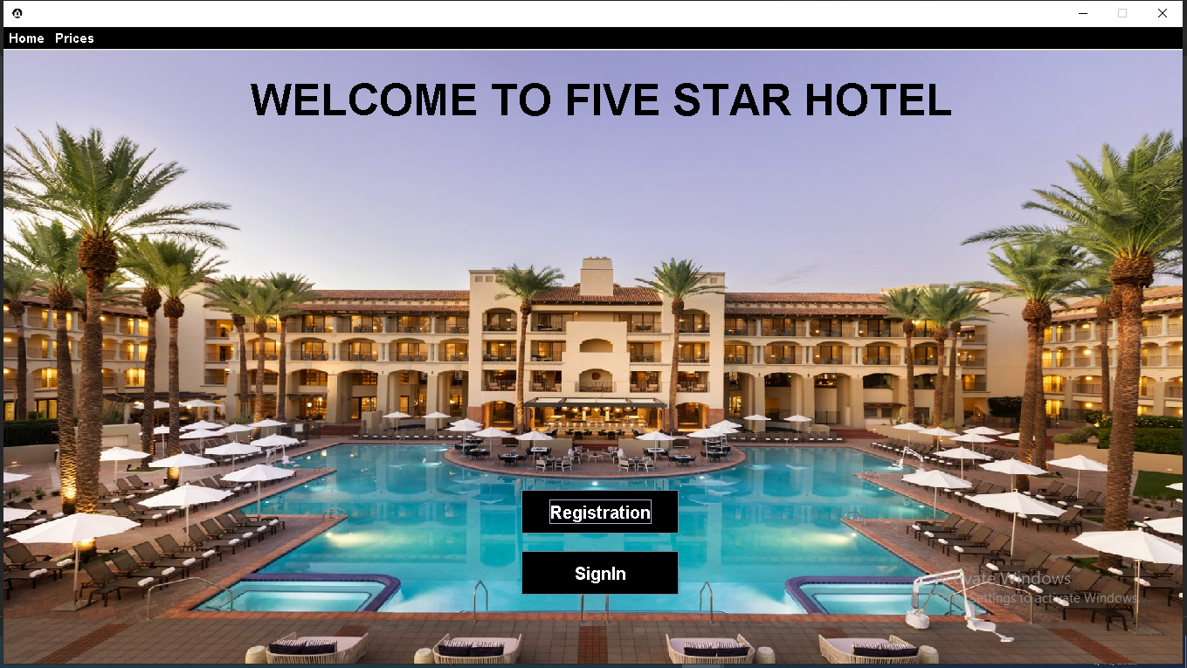

If we choose food Prices inside prices, then this page will be open. Also, that it has back button Through this we can back to our main menu.

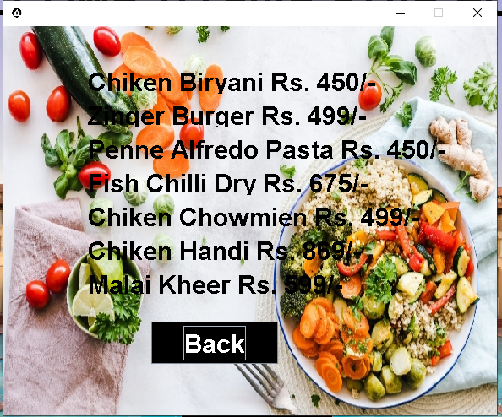

If we choose room prices inside prices then this page will be open. Also, that it has back button Through this we can back to our main menu.

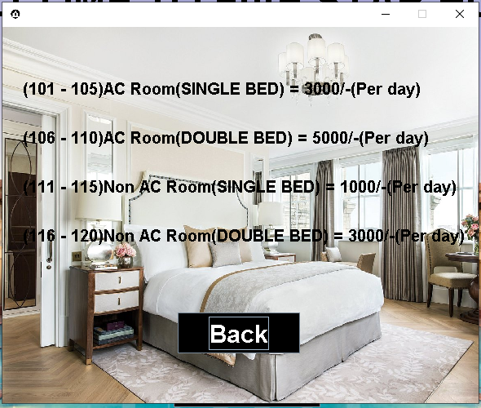

When we choose registration button (whether through main page or through menu bar inside then, this page would be appeared. (Above the main menu page)

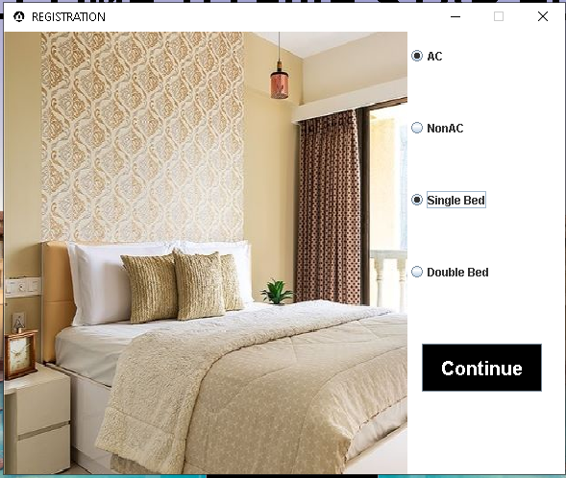

After selecting any room when we pressed the continue button then this page would be appeared next. In this page we have to give some personal details to book a room. Like this…

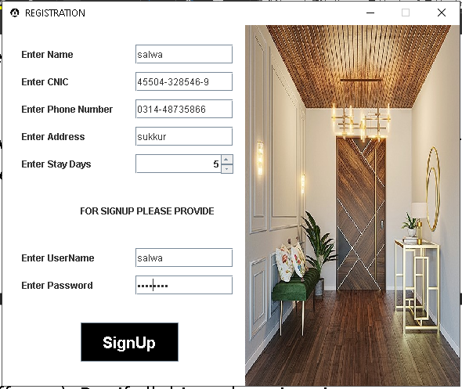

If we have same username with any other customer then it gives us error message (username should be different). But if all things there is unique username or password then we could be able to sign up successfully.

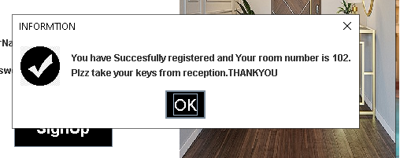

Here We can see that the program gives me room num 102.And after booking we can receive our room keys from the reception of the hotel. But how room num 102?

So, I distribute the room numbers like this…

(101 - 105) 🡪 AC rooms (Single Bed)

(106 – 110) 🡪AC rooms (Double Bed)

(111 - 115) 🡪Non-AC rooms (Single Bed)

(116 - 120) 🡪Non-AC rooms (Double Bed)

After that if we select sign in button then, this page would be appeared next. If the username and password will not be matched from the registered customer then, it gives error message (INVALID USERNAME OR PASSWORD). But if we give correct username and password then we can sign in successfully.

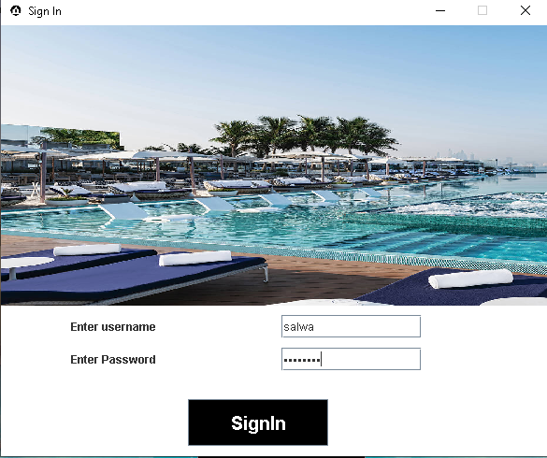

After successful sign in this page will appear.

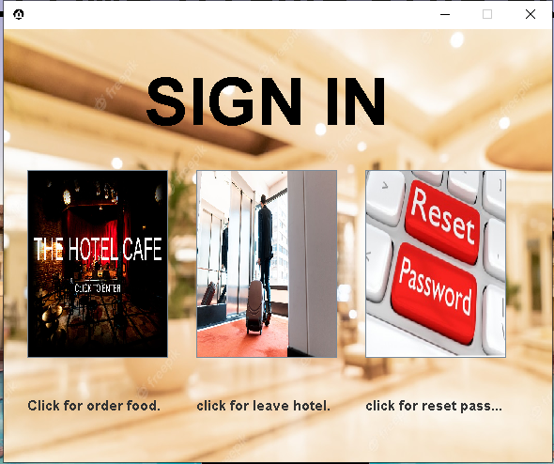

Here In this we have three buttons 1) Food 2) leave

3) reset password

If we choose food then this page would appear. In this we can order food (we can order more than one food by press the button selected after select each food item).

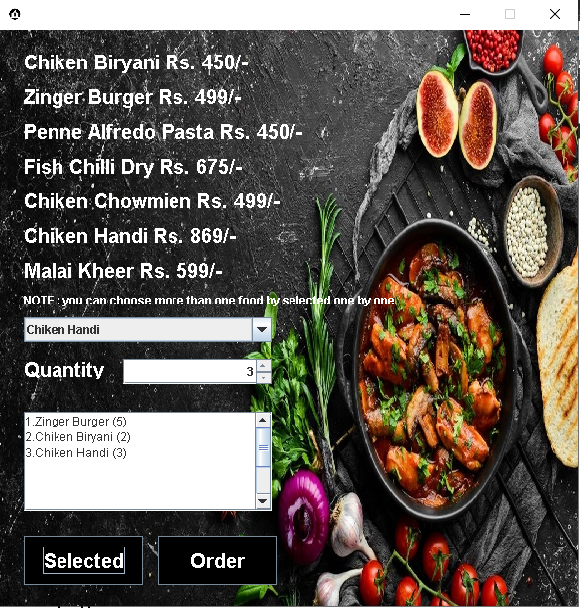

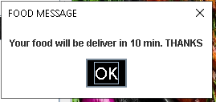

If we select reset password then we will be able to change our sign in password. If we enter different password and confirm password then it give us error message otherwise, password change successfully.

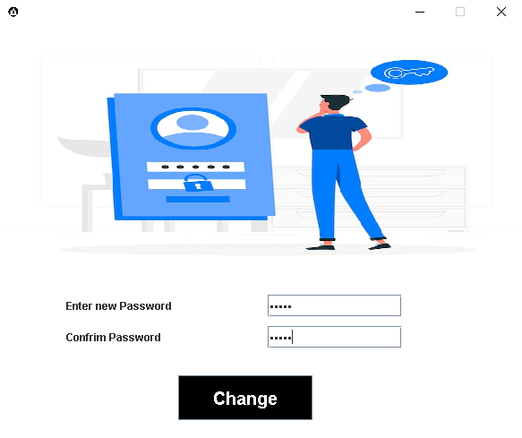

If password and confirm password are not same.

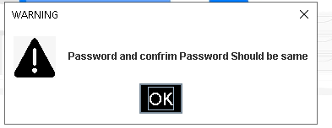

Otherwise, if both are same.

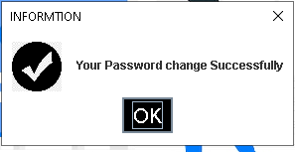

At last, If I press leave button then, this page will appear. It gives us our hotel bill. After that we have to our bill at reception before leaving the hotel.

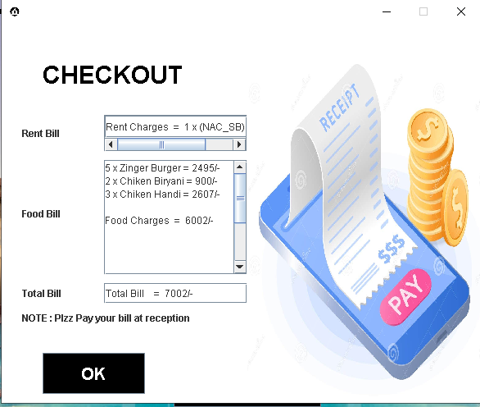

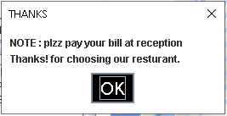

After press the order button this dialog box will be appear.